**Introduction to Mailgun**

Mailgun is an Email automation service. It has a very powerful set of inbuilt functions for sending emails. Developers can process their email with the help of Mailgun API

So in this lesson, we will learn how to create an account on Mailgun.

Creating an account on Mailgun

Step 1: Open <https://www.mailgun.com/> in browser.

Step 2: Click on [Sign Up](https://signup.mailgun.com/new/signup) button.

Step 3: Fill all the necessary details in SIGN UP form. Make sure you are unchecking the payment option. Below is the screenshot of filled sign up form.

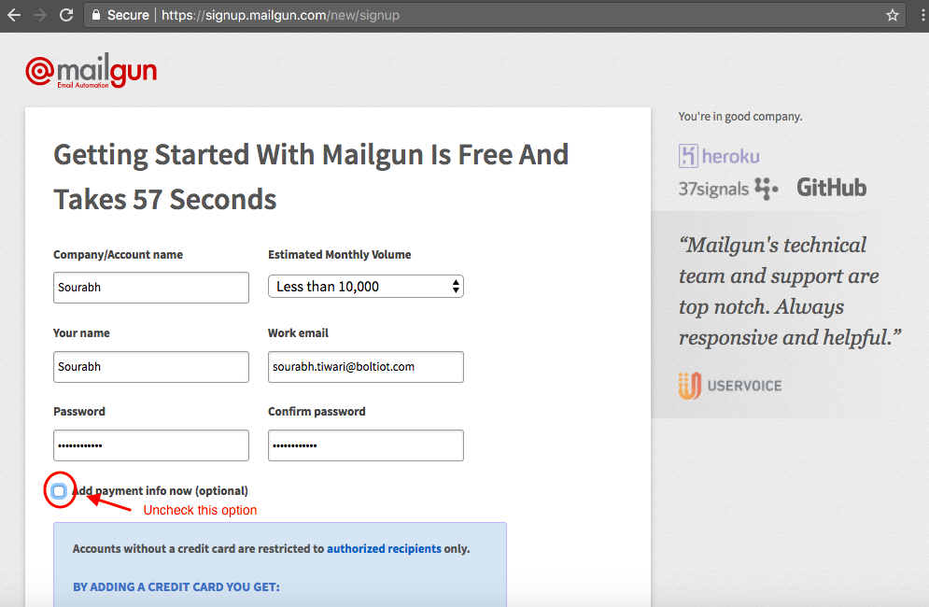

Step 4: You will get a verification mail having a link. Click on that link to verify your mail.

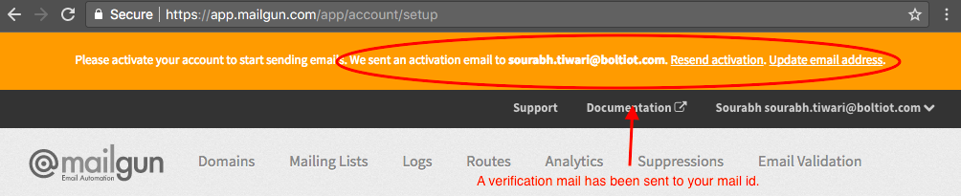

Step 5: To verify they will ask for phone number. Choose India as an option in the dropdown and then enter your phone number.

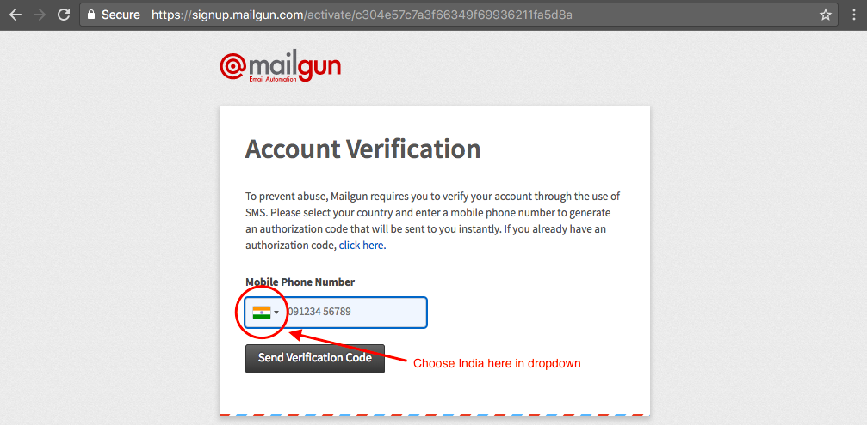

Step 6: After verification, scroll down to Sandbox Domain section. Click on Add Recipient button.

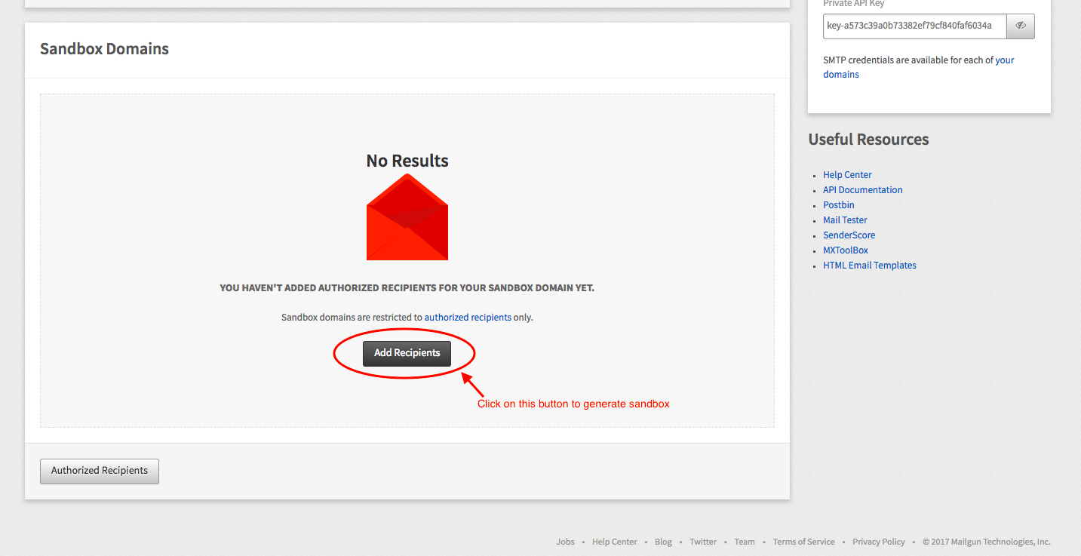

Step 7: Click on Invite New Recipient button.

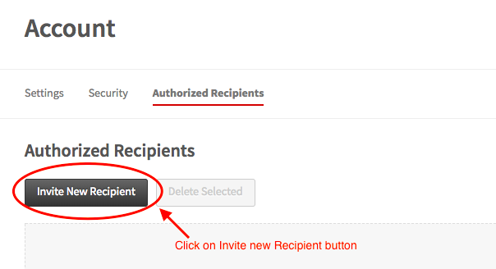

Step 8: Enter the Receipient Email ID. In this case enter your Email ID.

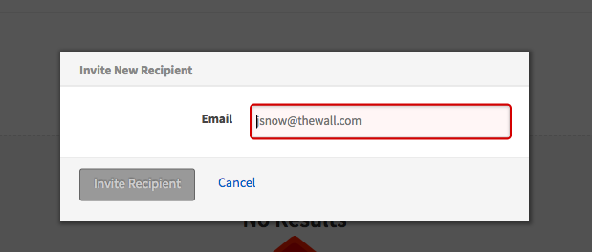

Step 9: After adding Email ID a new sandbox will be generated. Click on the ID of the newly generated sandbox. Refer below image for the same.

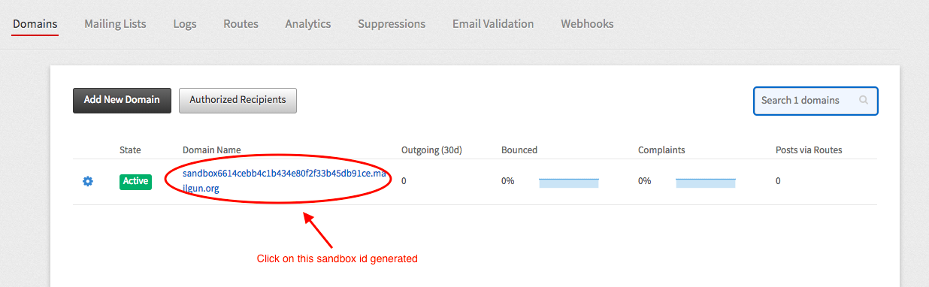

Step 10: The new screen will have all the necessary credentials that you want for sending an email. Copy all this credentials and save in the notepad.

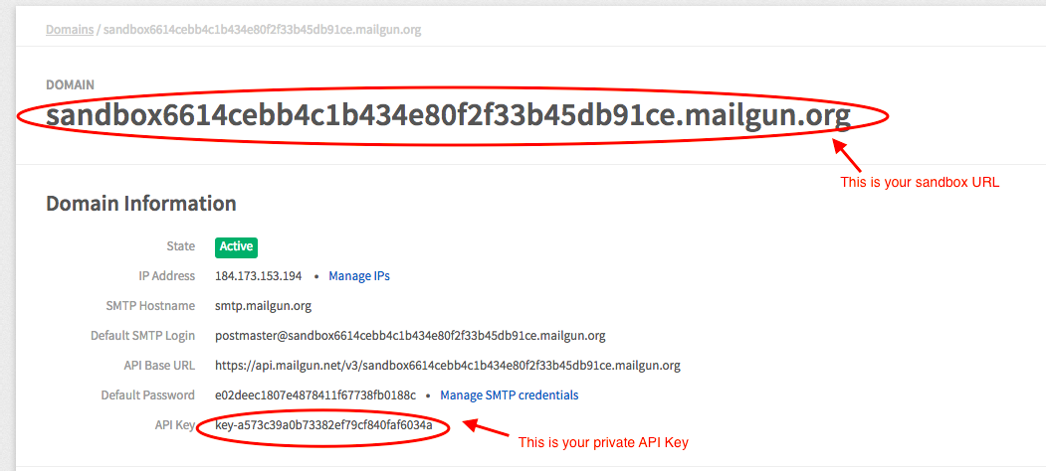

That's it. You have successfully created the account on Mailgun. In the next lesson, we will use Bolt Python library to create our own Email Alert system.

Note: The above "sensor_value" is the digital value, obtained from the LM35 sensor. In case you want to convert this value to temperature in degree Celsius, use the formula: Temperature=(100*sensor_value)/1024 ,where sensor_value = Data obtained from the LM35 sensor. The accuracy of this value obtained can be improved using an advanced calibrated technique.

* Save the file. Time to run the code. To do so type `sudo python temp_email.py` in terminal

Since we have written couple of print statement in the code. So the temperature data will get printed on the terminal. If that value falls outside the threshold range then an email will be sent to your registered Email ID.